Business Question and Visualization Report

Date | 21 September 2026
Team ID | MCA(Master of Computer Applications)
Project Name | Air Quality Intelligence: India Air Pollution Monitoring, Operational and Risk Analysis
Maximum Marks | 5 Marks

Visualization development refers to the process of creating graphical representations of data to facilitate understanding, analysis, and decision-making. The goal is to transform complex datasets into visual formats that are easy to interpret, enabling users to gain insights and make informed decisions. Visualization development involves selecting appropriate visual elements, designing layouts, and using interactive features to enhance the user experience. This process is commonly associated with data visualization tools and platforms, and it plays a crucial role in business intelligence, analytics, and reporting
Business Questions and Visualisation
The process involves defining specific business questions to guide the creation of meaningful and actionable visualizations in Power BI. Well-framed questions help in identifying key metrics, selecting relevant data, and building visualisation that provide insights.

Business Questions and Visualizations (Air Quality Intelligence)
1. Which cities have the highest average AQI?
Visualization: Horizontal bar chart — Average AQI by city.
Screenshot of visualisation:
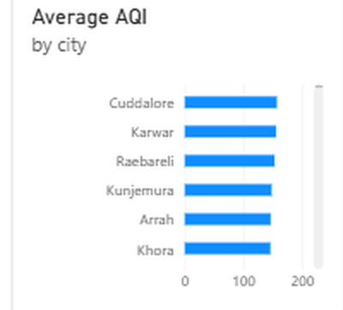

2. How does AQI trend over time?
Visualization: Line chart — Average AQI by date/month.
Screenshot of visualisation:
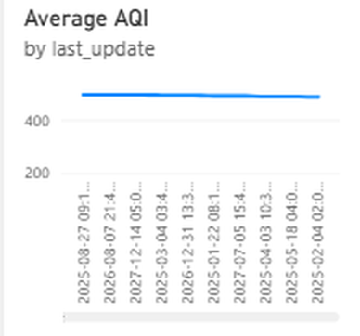

3. What is the geographic distribution of pollution across India?
Visualization: Map — AQI by city (latitude/longitude).
Screenshot of visualisation:
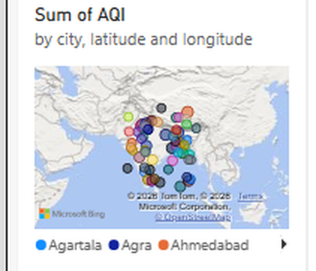

4. What share of readings fall into each AQI compliance category?
Visualization: Donut chart — Total Records by AQI_Bucket.
Screenshot of visualisation:
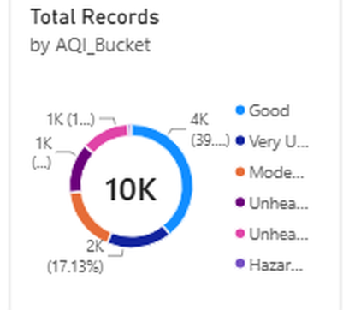

5. Which pollutants contribute most to overall AQI?
Visualization: Pie chart — Average pollutant concentration by pollutant_id.
Screenshot of visualisation:
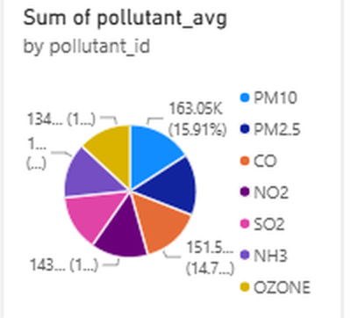

6. How does AQI vary by season?
Visualization: Column chart — Average AQI by Season.
Screenshot of visualisation:
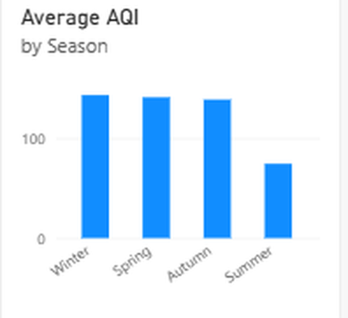

7. Is there a relationship between temperature and AQI?
Visualization: Scatter chart — Temperature (°C) vs AQI by city.
Screenshot of visualisation:
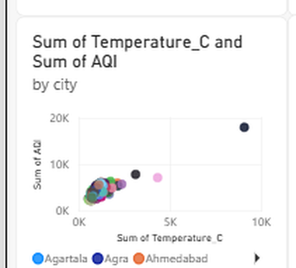

8. Is there a relationship between wind speed and AQI?
Visualization: Scatter chart — Wind Speed (km/h) vs AQI.
Screenshot of visualisation:
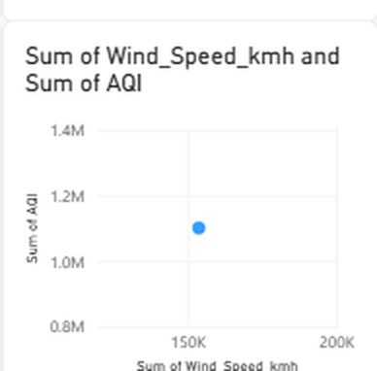

9. What factors most influence high AQI? (AI-assisted insight)
Visualization: Power BI Key Influencers visual — statistically ranks the drivers of increased AQI.
Screenshot of visualisation:
